Article of the Week #1
1. Survey the text
2. Mark your understanding and confusion by coding. AT LEAST 3 CODES.
3. Read closely and show evidence by CODING THE TEXT. [I=Interesting, ?=Question, *=Important, A=Agree, D=Disagree, C=Connects to something else I know. )
4. Look up vocabulary to clarify understanding
5. Write a summary statement.

6. Choose one reflection.

9/11/2001- The Day Our Lives Changed Forever
Source : DOGO News by Meera Dolasia on September 9, 2013

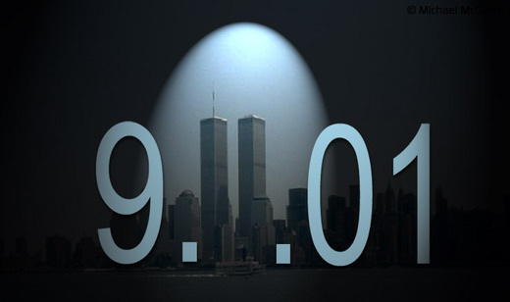

On Friday, September 11th, Americans and people all around the world will commemorate the 2,977 innocent lives that were lost in what will go down in history, as one of the most daring and unusual terrorist attacks ever. The tragedy not only changed the lives of the people directly affected by the attacks but also that of future, yet-to-be born generations.
That fateful Tuesday morning began like any normal day for most people living in the United States. Then at 8.46 EST came the first inkling that it was anything but, when American Airlines Flight 11 crashed right into the North Tower of New York City's World Trade Center. As the world debated about what had just happened, United Airlines Flight 175 zoomed in and this time, crashed into the South Tower of the world famous high-rise. By now it was obvious that this was no pilot error, but a daring attack upon the United States of America.
However before anybody could react, there was more bad news, this time from Arlington County, Virginia, where American Airlines Flight 77 had just plunged into the Pentagon, the headquarters of the United States military. Shortly after, United Airlines Flight 93 crashed in an empty field outside Shanksville, Pennsylvania. It was later discovered that the flight had been hijacked and re-directed to cause similar damage to either the Capitol or White House. But the brave passengers had somehow managed to derail the plan and help save thousands of lives, while sacrificing their own. All in all, 2,977 innocent people lost their lives that day, the effects of which rippled through to thousands of families, who even after twelve years are trying to make sense of this unnecessary act of violence.
The brazen attacks planned by Osama bin Laden, the leader of a terrorist group called Al Qaeda had involved 19 terrorists who split into four groups, each with an expert pilot and hijacked four commercial flights - United Flight 93 from New Jersey, American Flight 77 from Washington D.C., United Flight 175 and American Flight 11, both from Boston. The airplanes were selected because they were heading across the country either to Los Angeles or San Francisco and therefore, loaded with fuel.
For those who were at the scene or watched the entire chain of events unfold on live television, it is a memory that will forever be etched in their minds. However, for kids that were too young or not even born yet, it is hard to imagine what someone who was present at the scene may have experienced, which is the reason historical fiction writer Lauren Tarshis decided to write I Survived: The Attacks of September 11, 2001.

